**PP LAB WEEK-4**

# DSE VI-A2 Divansh Prasad 210968140

1) Write a parallel program using OpenMP to implement the Selection sort algorithm. Compute the efficiency and plot the speed up for varying input size and thread number.

#include <stdio.h>

#include <stdlib.h>

#include <time.h>

#include <omp.h>

#define MAX_VALUE 100

void generateArray(int arr[], int size) {

srand(time(NULL));

for (int i = 0; i < size; i++) {

arr[i] = rand() % MAX_VALUE;

}

}

void selectionSort(int arr[], int n) {

int i, j, min_idx;

for (i = 0; i < n - 1; i++) {

min_idx = i;

for (j = i + 1; j < n; j++) {

if (arr[j] < arr[min_idx]) {

min_idx = j;

}

}

if (min_idx != i) {

int temp = arr[i];

arr[i] = arr[min_idx];

arr[min_idx] = temp;

}

}

}

double sequentialSort(int arr[], int size) {

clock_t start, end;

double cpu_time_used;

start = clock();

selectionSort(arr, size);

end = clock();

cpu_time_used = ((double)(end - start)) / CLOCKS_PER_SEC;

return cpu_time_used;

}

double parallelSort(int arr[], int size, int num_threads) {

clock_t start, end;

double cpu_time_used;

start = clock();

#pragma omp parallel for num_threads(num_threads)

for (int i = 0; i < size; i++) {

selectionSort(arr, size);

}

end = clock();

cpu_time_used = ((double)(end - start)) / CLOCKS_PER_SEC;

return cpu_time_used;

}

int main() {

printf("Array Size\tThreads\tSequential Time (s)\tParallel Time (s)\tSpeedup\t\tEfficiency\n");

for (int size = 200; size <= 1000; size += 200) {

int arr[size];

generateArray(arr, size);

for (int num_threads = 2; num_threads <= 8; num_threads += 2) {

double sequential_time = sequentialSort(arr, size);

double parallel_time = parallelSort(arr, size, num_threads);

double speedup = sequential_time / parallel_time;

double efficiency = speedup / num_threads;

printf("%d\t\t%d\t%.6f\t\t%.6f\t\t%.6f\t%.6f\n", size, num_threads, sequential_time, parallel_time, speedup, efficiency);

}

}

return 0;

}

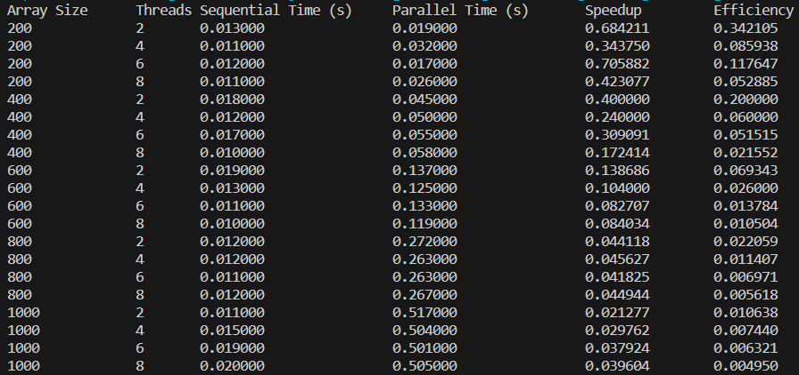

2) Write a parallel program using openMP to implement the following: Take an array of input size m. Divide the array into two parts and sort the first half using insertion sort and second half using quick sort. Use two threads to perform these tasks. Use merge sort to combine the results of these two sorted arrays.

#include <stdio.h>

#include <stdlib.h>

#include <time.h>

#include <omp.h>

void generateArray(int arr[], int size) {

srand(time(NULL));

for (int i = 0; i < size; i++) {

arr[i] = rand() % 100;

}

}

void insertionSortSequential(int arr[], int size) {

int i, key, j;

for (i = 1; i < size; i++) {

key = arr[i];

j = i - 1;

while (j >= 0 && arr[j] > key) {

arr[j + 1] = arr[j];

j = j - 1;

}

arr[j + 1] = key;

}

}

void insertionSortParallel(int arr[], int size, int num_threads) {

#pragma omp parallel for num_threads(num_threads)

for (int i = 1; i < size; i++) {

int key = arr[i];

int j = i - 1;

while (j >= 0 && arr[j] > key) {

arr[j + 1] = arr[j];

j = j - 1;

}

arr[j + 1] = key;

}

}

void quickSortSequential(int arr[], int low, int high) {

if (low < high) {

int pivot = arr[low];

int i = low;

int j = high;

while (i < j) {

while (arr[i] <= pivot && i <= high - 1) {

i++;

}

while (arr[j] > pivot && j >= low + 1) {

j--;

}

if (i < j) {

int temp = arr[i];

arr[i] = arr[j];

arr[j] = temp;

}

}

int temp = arr[low];

arr[low] = arr[j];

arr[j] = temp;

quickSortSequential(arr, low, j - 1);

quickSortSequential(arr, j + 1, high);

}

}

void quickSortParallel(int arr[], int low, int high, int num_threads) {

if (low < high) {

int pivot = arr[low];

int i = low;

int j = high;

while (i < j) {

while (arr[i] <= pivot && i <= high - 1) {

i++;

}

while (arr[j] > pivot && j >= low + 1) {

j--;

}

if (i < j) {

int temp = arr[i];

arr[i] = arr[j];

arr[j] = temp;

}

}

int temp = arr[low];

arr[low] = arr[j];

arr[j] = temp;

#pragma omp parallel sections num_threads(num_threads)

{

#pragma omp section

quickSortParallel(arr, low, j - 1, num_threads);

#pragma omp section

quickSortParallel(arr, j + 1, high, num_threads);

}

}

}

void merge(int arr[], int l, int m, int r) {

int i, j, k;

int n1 = m - l + 1;

int n2 = r - m;

int L[n1], R[n2];

for (i = 0; i < n1; i++)

L[i] = arr[l + i];

for (j = 0; j < n2; j++)

R[j] = arr[m + 1 + j];

i = 0;

j = 0;

k = l;

while (i < n1 && j < n2) {

if (L[i] <= R[j]) {

arr[k] = L[i];

i++;

} else {

arr[k] = R[j];

j++;

}

k++;

}

while (i < n1) {

arr[k] = L[i];

i++;

k++;

}

while (j < n2) {

arr[k] = R[j];

j++;

k++;

}

}

void sequentialSort(int arr[], int size) {

int mid = size / 2;

insertionSortSequential(arr, size);

quickSortSequential(arr, mid, size - 1);

merge(arr, 0, mid - 1, size - 1);

}

void parallelSort(int arr[], int size, int num_threads) {

int mid = size / 2;

#pragma omp parallel sections

{

#pragma omp section

{

insertionSortParallel(arr, size, num_threads);

}

#pragma omp section

{

quickSortParallel(arr, mid, size - 1, num_threads);

}

}

merge(arr, 0, mid - 1, size - 1);

}

int main() {

clock_t start, end;

double cpu_time_used_sequential = 0;

double cpu_time_used_parallel = 0;

int num_threads = 1;

printf("Array Size\tThreads\tSequential Time (s)\tParallel Time (s)\tSpeedup\t\tEfficiency\n");

for (int size = 200; size <= 1000; size += 200) {

for (num_threads = 2; num_threads <= 8; num_threads += 2) {

int arr[size];

generateArray(arr, size);

start = clock();

sequentialSort(arr, size);

end = clock();

cpu_time_used_sequential = ((double)(end - start)) / CLOCKS_PER_SEC;

start = clock();

parallelSort(arr, size, num_threads);

end = clock();

cpu_time_used_parallel = ((double)(end - start)) / CLOCKS_PER_SEC;

printf("%d\t\t%d\t%.6f\t\t%.6f\t\t%.6f\t%.6f\n", size, num_threads, cpu_time_used_sequential, cpu_time_used_parallel, cpu_time_used_sequential / cpu_time_used_parallel, (cpu_time_used_sequential / cpu_time_used_parallel) / num_threads);

}

}

return 0;

}

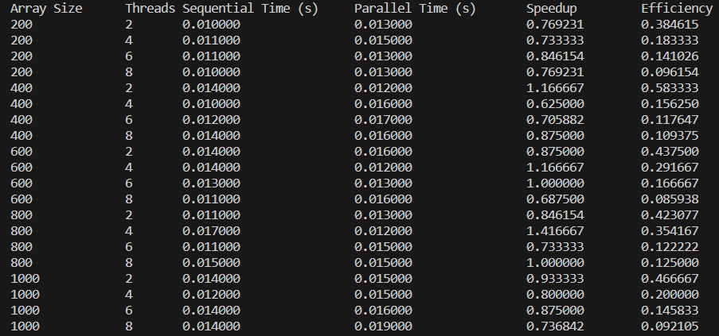

3) Write a parallel program using OpenMP to implement sequential search algorithm. Compute the efficiency and plot the speed up for varying input size and thread number.

#include <stdio.h>

#include <omp.h>

#include <time.h>

#include <windows.h>

#include <stdbool.h>

bool sequentialSearch(int element, int array[], int n) {

for (int i = 0; i < n; i++) {

if (array[i] == element) {

return true;

}

}

return false;

}

bool parallelSearch(int element, int array[], int n, int num_threads) {

bool found = false;

#pragma omp parallel for num_threads(num_threads) shared(found)

for (int i = 0; i < n; i++) {

if (array[i] == element) {

found = true;

}

}

return found;

}

int main() {

printf("Array Size\tThreads\t Sequential Time (s)\t Parallel Time (s)\tSpeedup\t\tEfficiency\n");

for (int size = 200; size <= 800; size += 200) {

int arr[size];

for (int num_threads = 2; num_threads <= 8; num_threads += 2) {

double sequential_time = 0;

double parallel_time = 0;

for (int i = 0; i < size; i++) {

arr[i] = rand() % 100;

}

int element_to_find = arr[rand() % 100];

clock_t start = clock();

sequentialSearch(element_to_find, arr, size);

clock_t end = clock();

sequential_time = ((double)(end - start)) / CLOCKS_PER_SEC;

start = clock();

parallelSearch(element_to_find, arr, size, num_threads);

end = clock();

parallel_time = ((double)(end - start)) / CLOCKS_PER_SEC;

double speedup = sequential_time / parallel_time;

double efficiency = speedup / num_threads;

printf("%d\t\t%d\t%.6f\t\t%.6f\t\t%.6f\t%.6f\n", size,num_threads, sequential_time, parallel_time, speedup, efficiency);

}

}

return 0;

}

